Midway Star Academy
Annual Report

FY 2023
Aqoon La'aan Waa Iftiin La'aan.
Absence of Knowledge is Absence of Light.
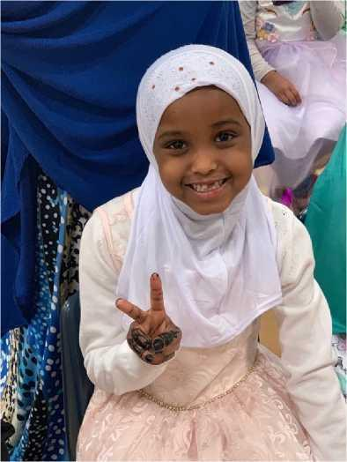

Table of Contents
1. School Information 2
2. Student Enrollment & Demographics 3
Student Enrollment 3
Student Demographics 3
3. Student Attendance, Attrition & Mobility 4
Student Attrition 4
Student Mobility 5
4. Staffing 6
Licensed Teachers 6
Teacher Retention 7
Administrative Staff 7
Diversity Equity and Inclusion 8
Equitable Access to Excellent and Diverse Educators 8
Teacher Professional Development 8
5. Academic Performance 9
NWEA 9
NWEA MAP Math Results Fall 2022 to Spring 2023, Grades K through 8 9
Students meeting 1 year’s academic growth 10
Below Grade Level Students meeting projected growth targets (1-year’s growth) 11
NWEA MAP Reading Results Fall 2022 to Spring 2023, Grades K through 8 14
Students meeting 1 year’s academic growth 14
At and/or Above Grade Level Students 16
6. Educational Effectiveness: Assessment & Evaluation 31
List of Administrators – Qualifications 33
Board Evaluation of the Director 34
Professional Development for Administrators 34
7. Governance and Management 34
Board of Directors 34
Board Training and Development 34
Board Election 35
Management 35
Professional Development of School Administrators 35
8. Staff and Parent Satisfaction 36
9. Curriculum, Program, and Innovative Practices 39
10. Future plans and next steps 40
11. Finances 40

School Information
CONTACT INFORMATION:
Midway Star Academy Charter School
1091 Snelling Avenue N.
Saint Paul, MN 55108
Telephone: (651)642-0667
Fax: (651)642-0668
GRADES SERVED: Kindergarten to 8th Grade
YEAR OPENED: 2005-06 Academic Year

VISION STATEMENT:
The academic focus of Midway Star Academy is to integrate students into the scholastic community of Minnesota and enable students to use their talents and experiences to achieve to the best of their ability.

MISSION STATEMENT:
Midway Star Academy will provide students with educational opportunities that are respectful of the students' background and culture, learning styles and interests, enabling them to meet high academic expectations in an environment that allows them to celebrate their own unique culture while learning American customs and what it means to be a citizen.

AUTHORIZER INFORMATION:
Pillsbury United Communities, Office of Public Charter Schools
Liaison: Larry McKenzie (LarryM@pillsburyunited.org; 612 302-3409)
1701 Oak Park Ave N, Minneapolis, MN 55411

Student Enrollment & Demographics

Student Enrollment
Number of Students Enrolled | 2017-18 | 2018-19 | 2019-20 | 2021-22 | 2021-22 | 2022-23
Kindergarten | 17 | 33 | 28 | 59 | 38 | 54
1st Grade | 35 | 31 | 25 | 53 | 56 | 63
2nd Grade | 23 | 50 | 22 | 42 | 50 | 70
3rd Grade | 27 | 42 | 30 | 43 | 50 | 60
4th Grade | 40 | 30 | 22 | 40 | 45 | 71
5th Grade | 34 | 36 | 21 | 38 | 44 | 60
6th Grade | 24 | 44 | 30 | 37 | 43 | 61
7th Grade | 25 | 42 | 36 | 36 | 39 | 60
8th Grade | 34 | 31 | 26 | 42 | 34 | 48
Total | 259 | 339 | 240 | 390 | 399 | 547

Student Demographics
Demographic Trends | 2018-19 | 2019-20 | 2020-2021 | 2021-22 | 2022-23
Total Enrollment | 339 | 240 | 390 | 399 | 547
Special Education | 22 (6.5%) | 14 (5.8%) | 20 (5.13%) | 24 (6.02%) | 45(8.22%)
English Learners | 260 (76.7%) | 133 (55.4%) | 305 (78.21%) | 289 (72.43%) | 367(67%)
Free/Reduced Lunch | 339 (100.0%) | 240 (100.0%) | >=90% | >=90% | >=90%
Black | 339 (100.0%) | 240 (100.0%) | 390 (100.00%) | 399 (100%) | 543(.992%)
Hispanic/Latino | 0 (0.0%) | 0 (0.0%) | 0 (0.00%) | 0 (0.00%) | 4(0.0007%)
Asian/Pacific Islander | 0 (0.0%) | 0 (0.0%) | 0 (0.00%) | 0 (0.00%) | 0 (0.00%)
White | 0 (0.0%) | 0 (0.0%) | 0 (0.00%) | 0 (0.00%) | 0 (0.00%)
Male |  |  | 207 (53%) | 203 (51%) | 279 (51%)
Female |  |  | 183 (47%) | 196 (49%) | 268 (49%)

Student Attendance, Attrition & Mobility
Midway Star understands that consistency of enrollment as well as high attendance are vital to give students the opportunity to engage and learn well through the entire curriculum. Therefore, our aim is to maintain enrollment for the entire year and to ensure our students attend regularly.
Student Attendance
This is a measure of students who attend school regularly and are not frequently absent. A student is considered consistently attending if they attend more than 90 percent of the time during the school year.
 | 2017-18 | 2018-2019 | 2019-2020 | 2021-2022 | 2021-2022 | 2022-23
Overall Student Attendance Rate | 95% | 92.9% | 95% | 99% | 98.67% | 96.52%

Consistent Attendance is a measure of students who attend school on a regular basis and are not frequently absent. A student is considered consistently attending if they attend more than 90 percent of the time the student is enrolled during the year.
 | Midway Star | MN Statewide
2021-22 Consistent attendance (MDE) | 91.3% | NA
2021-22 Consistent attendance (MDE) | NA | NA
2022-23 Consistent attendance (MDE) | 97.4% | 69.8%

Student Attrition
Significant efforts were made to engage students, families, and community stakeholders to retain (enrolled) as many students as possible during the school year. Disruptions to enrollment also disrupt student learning momentum.
Percentage of students* continuously enrolled between October 1 and the end of the school year | Max # Students Enrolled | # Continuously Enrolled | % Continuously Enrolled
October 1 to the end of the 2021-22 school year. | 500 | 400 | 80%
October 1 to the end of the 2022-23 school year. | 536 | 454 | 84.47%

Student Mobility
Significant efforts were made to engage community stakeholders in order to retain as many students as possible in keeping with the intent and definition of a community driven turnaround (serve the same students.) The spring to fall metric reflects success on this front.
Percentage of students who continued enrollment in the school from | # Students in Period | # Students Returning | % of Students Returning
October 1, 2020 to October 1, 2021. | 400 | 320 | 80%
October 1, 2021 to October 1, 2022. | 538 | 404 | 75.1%
October 1, 2022 to October 1, 2023. | 494 | 431 | 87.72%

Student enrollment success is also measured by considering student mobility. Mobility means that students come and leave from enrolling in the school during the school year. This may result from a lengthy period of absences, more than 10 days in a row, or from transferring from or into the school in the middle of the school year. This measure counts the percentage of students who were enrolled for 95% or more of the school year.
Percentage of students who were enrolled for 95% or more of the year | # Students Enrolled | # Students Enrolled 95% | % Students Enrolled 95+% of year
2020-21 school year | 403 | 383 | 95.0%
2021-22 school year | 547 | 415 | 75.8%
2022-23 school year | 494 | 411 | 83%

Staffing
Midway Star Academy strives to hire the best available licensed and non-licensed staff to meet the needs of its student population of primarily immigrants and English Learners. To the greatest extent possible, Midway Star Academy hires staff who are representative of the diverse cultures represented at the school. Midway Star Academy’ staffing during 2022-23 was as stated in the below tables.

Licensed Teachers
Licensed Staff Name | License and Assignment | Folder Number | Returned for 22-23 * | # of Yrs. Experience | Is person teaching in area of license? | Have an advanced degree?
Larson, Michelle | 2nd Grade Teacher | 382890 | R | 6 | Y | Master
Hoeffler, Maureen | 4th-grade Teacher | 332066 | R | 14 | Y
Warsame, Khalif | Academic Advisor | 477450 | R | 15 | Y
Herzi, Rukia | English Language Learner (ELL) | 502918 | R | 5 | Y
Ali, Safia | Kindergarten Teacher (K) | 517104 | R | 2 | Y | Masters
Pfeifer, Sam | Lead Teacher | 460545 | NR |  | Y | Masters
Song, Tom | P.E. Teacher | 371425 | R | 22 | Y | Masters
Dhaqane, Mukhtar | World Language Teacher | 483456 | R | 18 | Y
Olson, Ryan | 4th grade teacher | 1005558 | R | 3 | Y
Bejona, Chenee | 4th grade Teacher | 1018604 | R |  | Y
Said, Zaynab | Science 5-8 | 1012807 | R | 1 | y
Aded, Kaltoon | ELA Middle school | 1008739 | R | 2 | Y
Abdirashid, Kowsar | Kindergarten teacher | 1008002 | R | 2 | Y
Kimaiga, Eucabeth | SPED Teacher | 493239 | R | 5 | Y | Masters
Ali, Khadija | SPED Teacher | 362973 | R | 2 | Y | Masters
Ali, Hamdi | 3rd-grade | 511658 | NR | 5 | Y | Masters
Hussein, Hussein | SPED Teacher | 510032 | R | 3 | Y
Schroepfer, Cali | 1st grade teacher | 1009639 | R | 3 | Y
Deboer, Nicole | Kindergarten Teacher | 1004543 | R | 3 | Y | Masters
Samatar, Umelkayr | SPED Teacher | 511166 | R | 5 | Y | Masters
Noor, Nasra | 2nd grade teacher | 1005798 | R | 4 | Y
Hajiomar, Amal | 1st grade Teacher | 1016657 | NR | 1 | Y
Osman, Fahmo | 5th-grade | 509772 | R | 5 | Y | Masters
Osman, Zainab | 5th-grade | 1006525 | R | 3 | Y
Israelson, Raya | Social studies teacher | 514328 | NR | 4 | Y
Paula Stuelke | Middle school math teacher | 1005221 | NR | 3 | Y
* R = Returning, NR = Not Returning

Teacher Retention
Of the 26 licensed teaching staff members employed by Midway Star Academy in 2022-23, 21 returned in Fall 2023.
School Year | # Teachers Employed at End of School Year | # Teachers Returning at the Start of Next School Year | Retention Rates
2021-22 to 2021-22 | 28 | 17 | 60.7%
2021-22 to 2022-23 | 27 | 19 | 70.4%
2022-23 to 2023-24 | 26 | 21 | 80.8%

Administrative Staff
Person | Title | Licensure | Role
Mohamed Warsame February 2, 2020- June 2025 | Director | K12 Principal License | Oversees all school programs and operations under the board's oversight.
Hassan Hade | Assistant Director | K12 Principal License | Assists Director for programs and operations under the director's oversight
Nimco Ali | Operations Manager | HR manager | Oversees all operations under the director's oversight
Addison Filiatreaux | Instructional coach | Teacher | Oversees curriculum and teaching
Anisa Awale | Instructional Coach | Teacher | Oversees Curriculum & Teaching
* R = Returning, NR = Not Returning

Diversity Equity and Inclusion
Midway Star Academy is committed to preparing students and all involved with the school to live and work with diversity while also celebrating and honoring students’ cultural heritage. This school has 100.00% students of color who are also mostly second generation Americans. Our students are quite familiar with American customs, so the focus has been to create an environment where they learn and celebrate their Somali / East African heritage. For this reason, a school like Midway Star is as important for the community as it has ever been. For example, if not for students learning and practicing Somali Language within our World Language class, many of them would not be proficient enough in the Somali Language to communicate with their own grandparents and other community elders.

Equitable Access to Excellent and Diverse Educators
WBWF requires districts and charters to have a process in place to ensure students from low-income families, students of color, and American Indian students are not taught at disproportionate rates by inexperienced, out-of-field, and ineffective teachers. The legislation also requires that districts have strategies to increase access to teachers who reflect the racial and ethnic diversity of students.
Midway Star Academy students have experienced in-field, and effective teachers.
The WBWF statute also requires districts and charters to examine student access to licensed teachers who reflect the racial and ethnic diversity of students. A growing body of research has demonstrated that all students benefit when they are taught by racially and ethnically diverse staff throughout their school learning career, and students of color and indigenous students benefit even more. Consequently, working to increase teacher racial diversity is beneficial to all schools.
Midway Star Academy has been intentionally working to increase racial diversity among its staff. Midway Star Academy students have greater access to licensed teachers that reflect this racial and ethnic diversity of students.

Teacher Professional Development
Ongoing professional development of teachers in FY22-23 included standard training and professional development activities developed over the prior 3 years.
Teachers participate in daily professional development during team collaboration time; Wednesday afternoon whole group convenings and Friday afternoon professional development; regular whole group professional development on designated days; and job-embedded coaching. In addition, staff have access to online resources related to teaching and learning, school culture, and best practice.
Weekly PLCs were held by teacher groups. Results from benchmark assessment data, as well as NWEA data, are analyzed on a regular basis. Teachers collaborate to develop targeted interventions to help students that are not meeting grade level standards. They also use this time to identify any student that may need enrichment.
Primary areas covered during professional learning include:
- Student Personalized Learning
- Staff Professional Learning
- Learner Focused
- Differentiated
- Data Informed
- Technology Supported

Academic Performance
Following is a summary of Midway Star’s academic performance for the 2022-2023 school year. Included are summaries of publicly available data found on the MDE Report Card site that includes data on MCA tests, English Language Learner Progress, and Student Engagement. In addition, analysis of NWEA fall to spring results are also provided.

NWEA
In the 2022-2023 school year all students K-8 took the NWEA tests fall and spring and MCA Tests were also administered in the spring to students in grades 3-8. NWEA generates expected full-year growth targets for each student based on their grade level and ranking. These targets create a useful comparable measure for individual growth. The NWEA national average of all students in all schools who show growth is 50%. Students who beat 50% in measures are meaningful. Most Midway Star Academy students start school below grade level. Often, students below grade level achieve greater growth compared to at or above grade level students.

NWEA MAP Math Results Fall 2022 to Spring 2023, Grades K through 8
NWEA Results from Fall 2022 to Spring 2023 show strong participation. The number of students who completed the Fall and Spring tests are shown below. This school year was much more like learning prior to the Pandemic.
 | K | Grade 1 | Grade 2 | Grade 3 | Grade 4 | Grade 5 | Grade 6 | Grade 7 | Grade 8 | All Students
Math | 32 | 37 | 43 | 28 | 32 | 34 | 34 | 33 | 23 | 296

Students meeting 1 year’s academic growth
Midway Star’s goal for student growth is that 50% or more of students who have been continuously enrolled (having tested all seasons August through May) will be on track to make at least 1 year’s growth. NWEA assessments measure a year’s growth when students achieve their projected growth in RIT scores. A student’s projected growth value is determined by grade level and the student’s percentile ranking based on the first assessment RIT score. IN FY23, 48.3% of all students achieved their projected growth targets in Math, marking a 3.7% point increase. This progress brings us closer to our goal of reaching 50%
Results by Grade Level show that 4 out of the 9 grades had above 50% of students meeting their projected growth in math.

Grade Level | # Students Tested | # Met Target | # Not Met Target | % Met Target (all students)
K | 32 | 14 | 18 | 43.8%
1 | 37 | 13 | 24 | 35.1%
2 | 43 | 17 | 26 | 39.5%
3 | 28 | 18 | 10 | 64.3%
4 | 32 | 13 | 19 | 40.6%
5 | 34 | 19 | 15 | 55.9%
6 | 34 | 21 | 13 | 61.8%
7 | 33 | 17 | 16 | 51.5%
8 | 23 | 11 | 12 | 47.8%
All Students | 296 | 143 | 153 | 48.3%

The chart below shows the percent of cumulative growth for students making expected growth. Of the 162 out of 313 students that made their fall to spring expected growth target in math, their cumulative
growth was 152%. These 162 were expected to grow by a total of 1958 points, yet they actually achieved 2989 points.
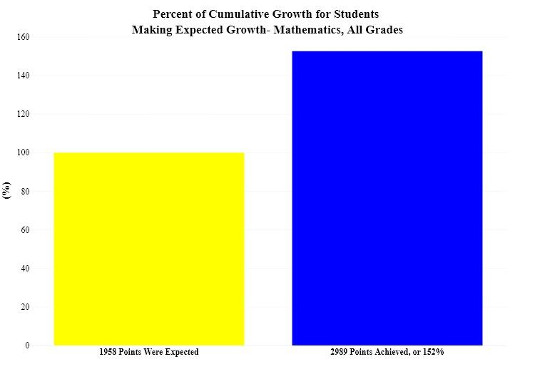

Students at/above or below their grade level
NWEA ranks students in the same grade taking the same assessment by their RIT scores. Students’ percentile ranking rates how close students are to normal academic achievement at that time in the school year. Students ranking at or below 40% can be considered below grade level. The primary purpose of charter schools is to improve all pupil learning and all student achievement. However, when students start achieving at below grade level, as many who start at Midway Star do, how well are these students doing? Consider that the proportion of students who qualify for the Free/Reduced Lunch program is over 90% and the proportion of students who are English Language Learners is around 60%.
At or Above Grade-Level Students
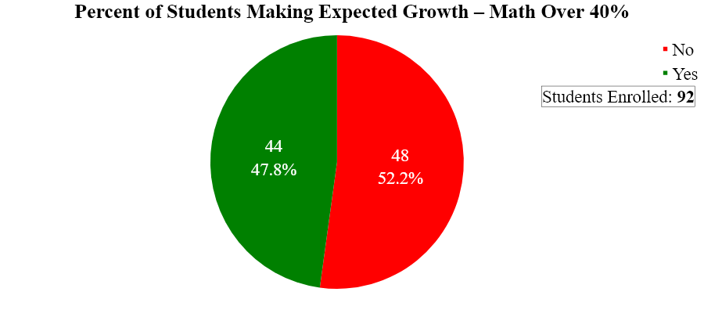
Midway Star utilizes programs and best practices to meet students at their level and help them to improve. IF FY23, 92 students started the year achieving 40% or higher on their NWEA math assessment. Target growth goals are made for these students as it is important to monitor the growth and progress of ALL our students The two charts below show data for students scoring at or over the 40% rank. 47.8% or 44 students met their growth target.

Of the 44 out of 92 students that made their fall to spring expected growth target in math over 40 percentile rank, their cumulative growth was 143%. These 44 were expected to grow by a total of 509 points, yet they actually achieved 728 points.
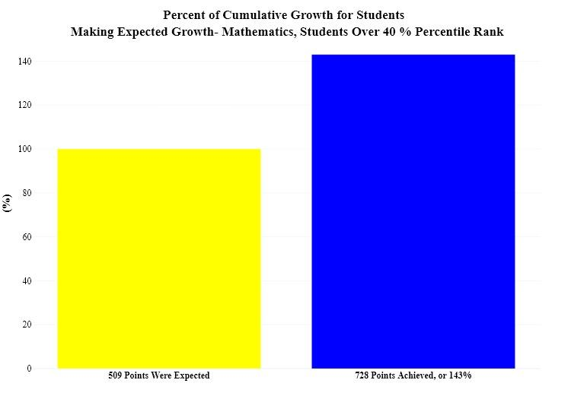

Below Grade Level Students meeting projected growth targets (1-year’s growth)
The solution for below-grade-level students is to help them grow at least a full year’s worth of learning. It is better if they grow even more. Typically, students below grade level can make greater progress in a year than those at or above grade level. Those who are in the higher percentile tend to drift downward over time unless they are well-supported to continue learning beyond their current levels. In NWEA measurements, students and groups of students who achieve or improve better than 50% of all students in the same group are significant. 53.4% of them met their projected growth targets. Better than 50% is significant.
The following charts show the percent of students that scored under 40% that made their expected growth target.
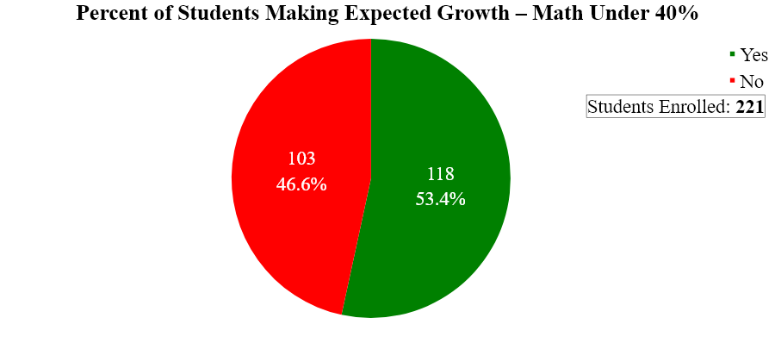

Of the 118 out of 221 students that made their fall to spring expected growth target in math under 40 percentile rank, their cumulative growth was 156%. These 118 were expected to grow by a total of 1449 points, yet they actually achieved 2261 points.
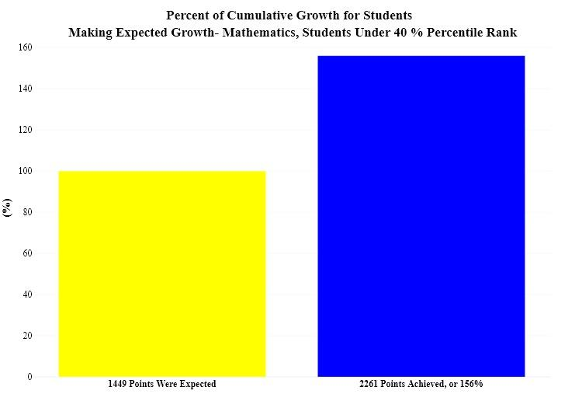

NWEA MAP Reading Results Fall 2022 to Spring 2023, Grades K through 8
NWEA MAP Reading tests were given at the same time as the Math tests.
Results below refer to students in grades K through 8 in Fall 2022. The number of students who tested in Reading Fall to Spring are:
 | K | Grade 1 | Grade 2 | Grade 3 | Grade 4 | Grade 5 | Grade 6 | Grade 7 | Grade 8 | All Students
Reading | 32 | 35 | 33 | 34 | 32 | 35 | 30 | 24 | 28 | 283

Students meeting 1 year’s academic growth
The goal for student growth is that 50% or more of students who have been continuously enrolled (having tested all seasons August through May) will be on track to make at least 1 year’s growth. NWEA assessments measure a year’s growth when students achieve their projected growth in RIT scores. A student’s projected growth value is determined by grade level and the student’s percentile ranking based on the first assessment RIT score. The percentage of all students who met their projected growth targets in Reading was 52.6%, and increase of 5.6% from FY22. The information is represented in the table below. This goal was met in Reading.

Grade Level | # Students Tested | # Met Target | # Not Met Target | % Met Target (all students)
K | 38 | 20 | 18 | 52.6%
1 | 43 | 19 | 24 | 44.2%
2 | 46 | 25 | 21 | 54.3%
3 | 34 | 22 | 12 | 64.7%
4 | 39 | 28 | 11 | 71.8%
5 | 37 | 18 | 19 | 48.6%
6 | 35 | 19 | 16 | 54.3%
7 | 34 | 11 | 23 | 32.4%
8 | 23 | 11 | 12 | 47.8%
All Students | 329 | 173 | 156 | 52.6%

Of the 166 out of 320 students that made their fall to spring expected growth target in reading, their cumulative growth was 152%. These 166 were expected to grow by a total of 1873 points, yet they actually achieved 2855 points.

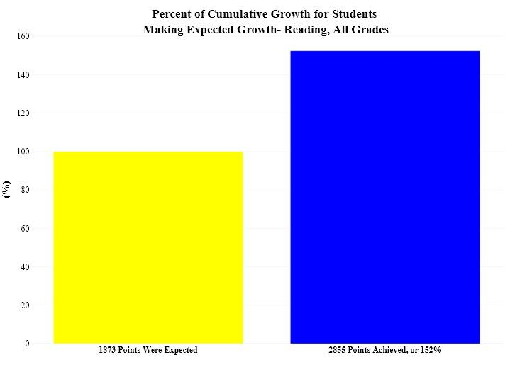

Below Grade Level Students meeting projected growth targets (1-year’s growth)
Of the 203 students below grade level, 53.7% of them met their projected growth targets. The second chart shows the total number of points these students achieved.

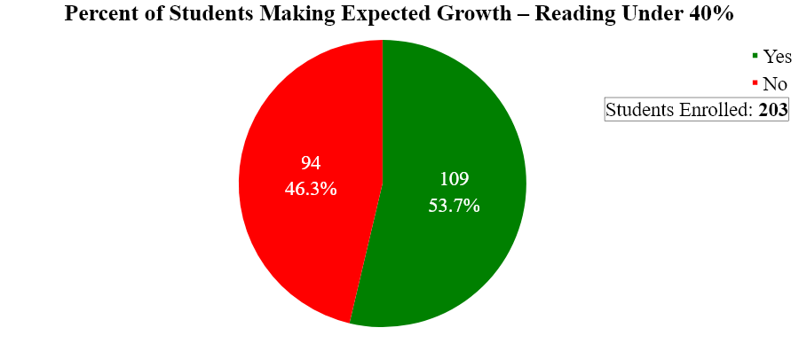

Of the 109 out of 203 students that made their fall to spring expected growth target in reading under 40 percentile rank, their cumulative growth was 153%. These 109 were expected to grow by a total of 1343 points, yet they actually achieved 2067 points.

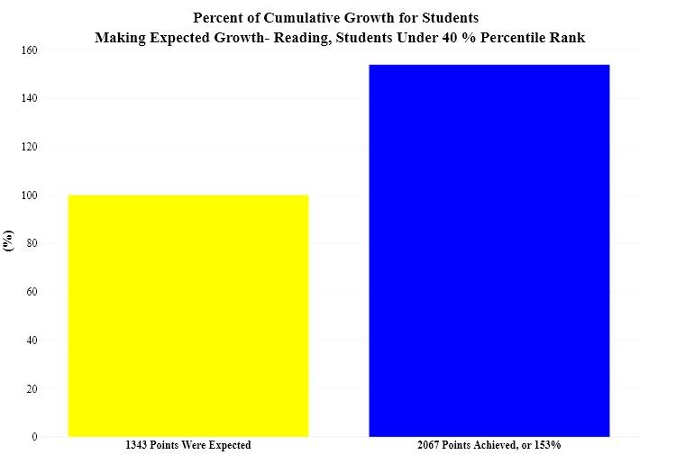

At and/or Above Grade Level Students
Of the 117 students at or above grade level 48.7% of them met their projected growth targets. The second chart shows the total number of points these students achieved.

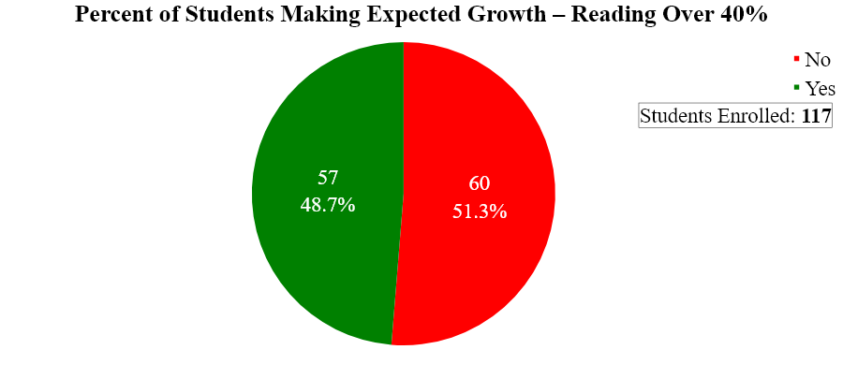

Of the 57 out of 117 students that made their fall to spring expected growth target in reading over 40 percentile rank, their cumulative growth was 148%. These 57 were expected to grow by a total of 530 points, yet they actually achieved 788 points.

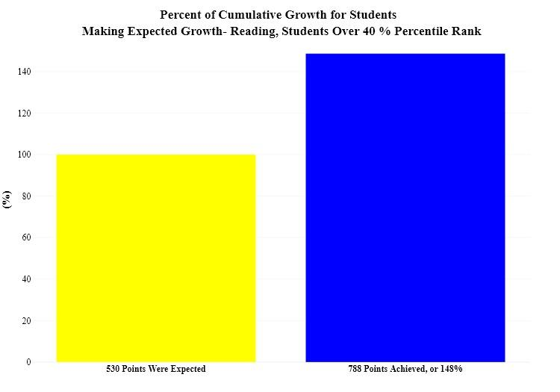

Summary of Data from MDE Report Card
All Minnesota public school students are assessed for academic proficiency in Reading based on MCA assessment results. The MCA was administered again in Spring 2023. The MCA Data is reported from available data files at the MDE Website. The MN Report Card site also presents some of the data, as was suitable to report.
Midway Star nearly doubled their scores of students meeting or exceeding grade level proficiency in Math and Reading from FY22-FY23. Data from the most recent MCAs are showing that Midway students are not only returning to high levels of achievement in Math, Reading, and Science as seen prior to COVID, but they are also surpassing those scores.

Subject | 2018 | 2019 | 2020 | 2021 | 2022 | 2023
Math | 9.7% (18) | 17.5% (36) | N/A (N/A) | 3.5% (7) | 14.1% (33) | 33.7%
Reading | 14.7% (27) | 19.4% (40) | N/A (N/A) | 12.7% (26) | 17.8% (42) | 35.2%
Science | 9.1% (6) | 4.8% (3) | N/A (N/A) | 0.0% (0) | 12.2% (10) | 13.7%

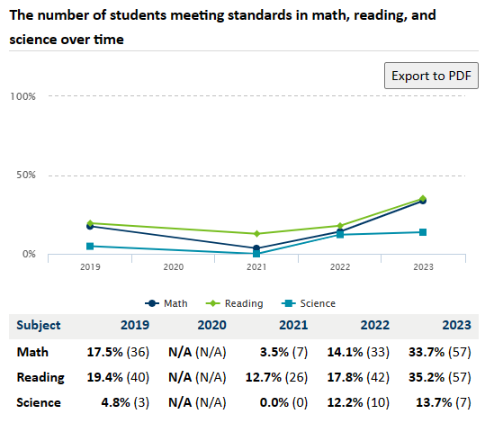

Northstar Achievement In Math
20.2% (or 52) of all Midway Star students (258) achieved math standards in FY2023. Nearly all students attending Midway Star Academy qualify for Free/Reduced Lunch and are Black/African American. The performance data for these two groups indicate that FRP students at Midway Star Academy are achieving significantly higher scores compared to students with similar demographics attending Minneapolis Public Schools. In addition the Black/African American students attending Midway Star are performing at a slightly higher percentage than Black/African American students statewide and significantly higher than peers attending Minneapolis Public Schools.
 | Statewide | Midway Star Academy | Minneapolis Public Schools
Math achievement rate for All students | 42.8% | 20.2% | 31.2%
FRP Students | 25.0% | 21.3% | 10.5%
Black/African American Students | 19.0% | 20.0% | 8.0%

Math Achievement: Free Reduced Meals
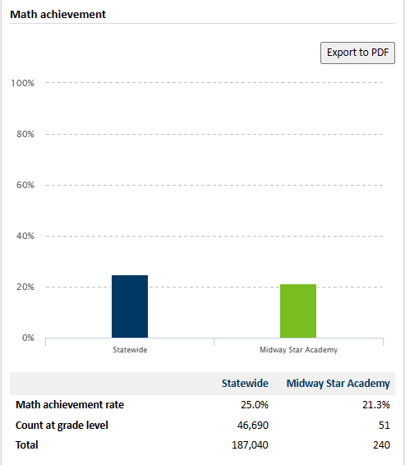

Math Achievement: Black/African American
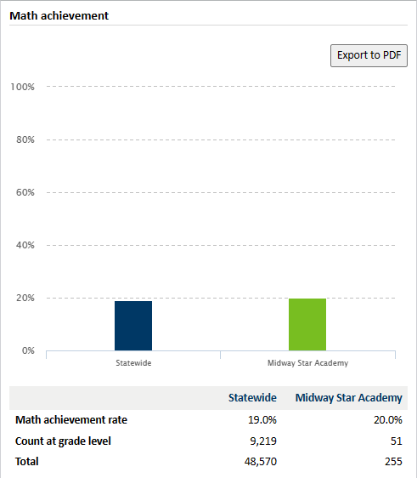

North Star Academic Achievement in Reading
20.9% (or 54) of all Midway Star students (258) achieved reading standards in FY2023. Nearly all Midway Star students qualify for Free or Reduced Lunch. 29.4% (or 42,371) of all MN Free and Reduced Lunch students (144,067) achieved standards in math. Both FRP and Black/African American students are performing at significantly higher rates than their peers attending Minneapolis Public Schools.
 | Statewide | Midway Star Academy | Minneapolis Public Schools
Reading achievement rate | 47.6% | 20.9% | 38.1%
FRP Students | 31.4% | 21.3% | 16.7%
Black/African American Students | 28.1% | 20.8% | 14.5%

Reading Achievement: Free Reduced Price Meals
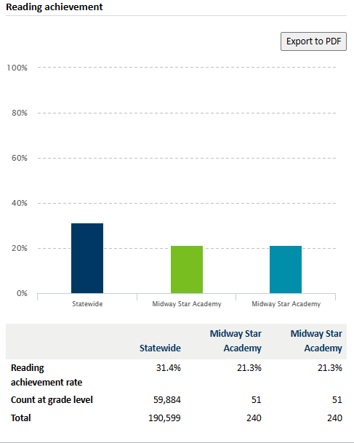
Reading Achievement: Black/African American
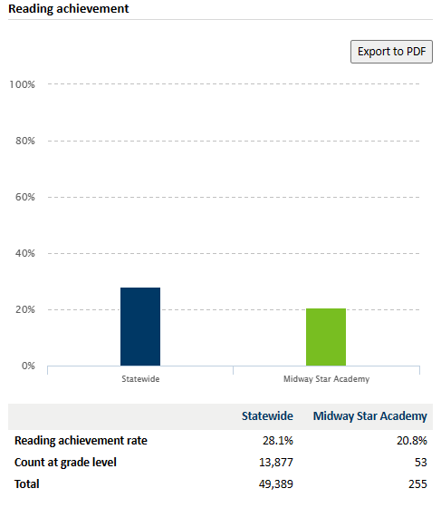

North Star Academic Progress
Math academic progress
A higher percentage of students at Midway Star Academy are improving their achievement levels when compared to students statewide. This trend holds true for all students as well as FRP students.
An estimated 25% of students at Midway Star maintained their achievement levels. When compared to students statewide, Midway Star appears to be maintaining achievement levels at a lower percentage. However, almost 100% of students attending Midway Star qualify for Free and/or Reduced Programs. When FRP students at Midway Star are compared to FRP students statewide, that gap decreases greatly. Midway Star is only 2.7% points less than the statewide level.
Overall, more than half the students (55.8%) are maintaining or improving achievement levels in math. These numbers are similar to the state where 56.4% of students maintained or improved. However, only 41.4% of FRP students statewide maintained or improved their achievement levels compared to 56.2% of FRP students attending Midway Star. The gap between the two percentages indicates that Midway Star’s educational programs and strategies may be more successful in helping FRP students.

 |  | Statewide (All students) | Statewide (FRP students) | Midway Star Academy (All students) | Midway Star Academy (FRP students)
Achievement level improved | Count | 41,951 | 16,674 | 35 | 35
 | Percent | 14.8% | 13.7% | 31.0% | 31.3%
Achievement level maintained | Count | 117,331 | 33,730 | 28 | 28
 | Percent | 41.5% | 27.7% | 24.8% | 25.0%
Achievement level decreased or stayed "does not meet standards" | Count | 123,370 | 71,431 | 50 | 49
 | Percent | 43.6% | 58.6% | 44.2% | 43.8%
Total count of students | Count | 282,652 | 121,835 | 113 | 112
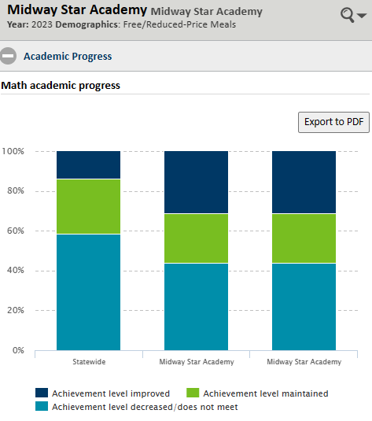
Reading academic progress
At both the state and Midway Star Academy level, FRP students generally had slightly higher percentage points of improvement in their achievement levels compared to all students. In both data sets, students at Midway Star had a higher percentage of students improving their reading achievement levels.
When comparing all students, the state had a higher percentage of students maintaining their achievement levels. When we compare FRP students, we see that percentage is almost the same.
Overall, the statewide dataset shows that a higher percentage of students decreased their achievement levels compared to Midway Star Academy. Overall, 53.4% of FRP Midway students either maintained or improved their reading achievement levels vs. only 48.1% of FRP students statewide. This suggests that in terms of reading achievement, FRP students at Midway Star Academy are performing relatively better than their counterparts across the state.
 |  | Statewide (All students) | Statewide (FRP students) | Midway Star Academy (All students) | Midway Star Academy (FRP students)
Achievement level improved | Count | 51,212 | 21,529 | 24 | 24
 | Percent | 18.0% | 17.6% | 22.9% | 23.3%
Achievement level maintained | Count | 119,173 | 37,524 | 32 | 31
 | Percent | 42.05 | 30.6% | 30.5% | 30.1%
Achievement level decreased or stayed "does not meet standards" | Count | 113,661 | 63,591 | 49 | 48
 | Percent | 40.0% | 51.9% | 46.7% | 46.6%
Total count of students | Count | 284,026 | 122,644 | 105 | 103
Reading Achievement: Free/Reduced-Price Meals
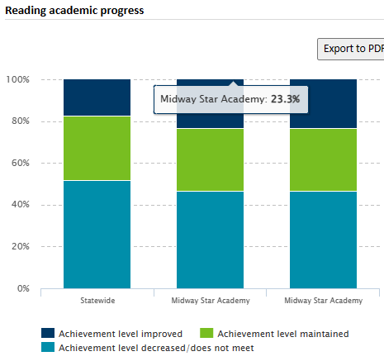

2023 Math Student Achievement Levels
Between 2022 and 2023, there has been significant improvement in students’ proficiency in math. In 2022, there were 33 students proficient in math, which represented 14.10% of the total. In 2023, the number of proficient students increased to 52, or 34.44% of the total. That’s an increase of 20.34%.
Year |  | Proficient | Does not meet | Partially meets | Meets | Exceeds | Total Tested
2022 | Count | 33 | 147 | 54 | 29 | 4 | 234
2022 | Percent | 14.10% | 62.82% | 23.08% | 12.39% | 1.71%
2023 | Count | 52 | 54 | 45 | 42 | 10 | 151
2023 | Percent | 34.44% | 35.8% | 29.8% | 27.8% | 6.6%
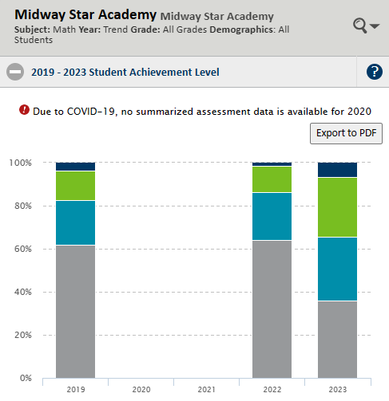

2023 Reading Student Achievement Levels
In the area of reading, Midway Star Academy students have shown a significant increase in proficiency between FY22 and FY23. In 2022, there were 42 students proficient in reading, which represented 17.80% of the total. In 2023, the number of proficient students increased to 54, which accounts for 36.99% of the total. The data demonstrates a substantial increase in the percentage of proficient students from 2022 to 2023, indicating a positive trend in students’ reading and comprehension skills. Students have made significant progress in reading between the two years.
Year |  | Proficient | Does not meet | Partially meets | Meets | Exceeds | Total Tested
2022 | Count | 42 | 142 | 52 | 37 | 5 | 236
2022 | Percent | 17.80% | 73.40% | 19.70% | 6.90% | 2.12%
2023 | Count | 54 | 59 | 33 | 50 | 4 | 146
2023 | Percent | 36.99% | 40.4% | 22.6% | 34.2% | 2.7%
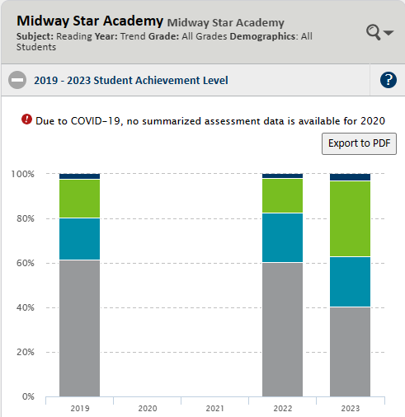
Are English learners progressing?
North Star Progress Toward ELP
The "average progress toward target" is the average amount of progress English learners made towards their targets. For example, an average progress toward a target of 75 would mean that English learners, on average, made it 75 percent of the way to their targets.
In FY2023 an average of 39.6% of Midway Star English Language Learners (223) made progress toward their ELP targets. By comparison, an average of 47.3% of All MN English Language Learners (63,509) made progress toward their ELP targets.
 | Statewide | Midway Star Academy
Average progress toward target | 47.3% | 39.6%
Total | 63,509 | 223
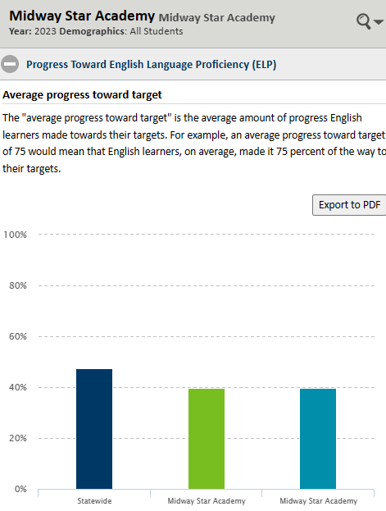
ACCESS for ELLs Achievement Levels, Composite/Overall ELL Achievement in FY2023
 | Level 6 | Level 5 | Level 4 | Level 3 | Level 2 | Level 1
Percent | N/A | 2.3% | 19.3% | 39.85 | 33.0% | 5.7%
Count | N/A | 4 | 34 | 70 | 58 | 10
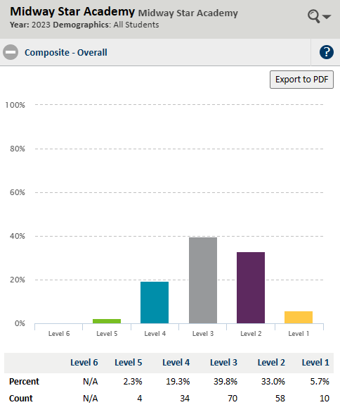
Charter Contract Goals Reporting for Midway Star Academy:
School Year: 2022-24
ACADEMIC GOALS | REPORTED PROGRESS | EVIDENCE
1.1. Growth Goal 1.1: Math  At least 50% of students will meet their annual growth goal in math.  From FY22 to FY24, the aggregate percentage of all students assessed in the Fall who achieve their Spring benchmark goal in Mathematics as measured by the NWEA/MAP suite of assessments will be within the target range.  Parameters for Goal  Student Population: Students that take a fall and spring test annually.  As measured by: NWEA Measure of Academic Progress - Goal Targets.  Targets  Exceeds Expectations: 60% of students or more met their growth goal.  Meets Expectations: 50% of students or more met their growth goal.  Approaching Expectations: 45-49% of students met their growth goal.  Of Concern: Less than 45% of students met their growth goal. | ☐Goal exceeded expectations  ☒Goal met expectations  ☐Goal approached expectations  ☐Goal attainment is of concern | Goal Result:  FY22: 60.1% of all students met their annual growth goal in math.  FY23: 48.3% of all students met their annual growth goal in math  As measured by: NWEA
1.2. Growth Goal 1.2: Math  At least 50% of below grade level students in the fall will meet their annual growth goal in math and those students cumulatively will make over 120% of expected growth in Math.  Parameters for Goal  Student Population: Students that take a fall and spring test annually.  As measured by: NWEA Measure of Academic Progress - Goal Targets.  Targets  Exceeds Expectations: 50% of students or more who met their growth goals and also met the 140% growth goal.  Meets Expectations: 50% of students or more who met their growth goals and also met the 120% growth goal.  Approaching Expectations: 50% of students who met their growth goals and also met the 100-120% growth goal.  Of Concern: Less than 50% of students who met their growth goals and met the 120% growth goal. | - ☒Goal exceeded expectations  - ☐Goal met expectations  - ☐Goal approached expectations  - ☐Goal attainment is of concern | Goal Result:  FY22: 59.2% of below grade level students met their annual growth goal in math.  The growth of these students was 159.9%  FY23: 53.4% of below grade level students met their annual growth goal in math.  The growth of these students was 145.2%  As measured by: NWEA
2.1. Growth Goal 2.1: Reading  At least 50% of students will meet their annual growth goal in reading.  Parameters for Goal  Student Population: Students that take a fall and spring test annually.  As measured by: NWEA Measure of Academic Progress - Goal Targets.  Targets  Exceeds Expectations: 60% of students or more met their growth goal.  Meets Expectations: 50% of students or more met their growth goal.  Approaching Expectations: 45-49% of students met their growth goal.  Of Concern: Less than 45% of students met their growth goal. | - ☐Goal exceeded expectations  - ☒Goal met expectations  - ☐Goal approached expectations  - ☐Goal attainment is of concern | Goal Result:  FY22: 52.6% of all students met their annual growth goal in reading.  FY23: 51.9% of all students met their annual growth goal in reading.  As measured by: NWEA
2.2. Growth Goal 2.2: Reading  At least 50% of below grade level students in the fall will meet their annual growth goal in math and those students cumulatively will make over 120% of expected growth in Reading.  Parameters for Goal  Student Population: Students that take a fall and spring test annually.  As measured by: NWEA Measure of Academic Progress - Goal Targets.  Targets  Exceeds Expectations: 50% of students or more who met their growth goals and also met the 140% growth goal.  Meets Expectations: 50% of students or more who met their growth goals and also met the 120% growth goal.  Approaching Expectations: 50% of students who met their growth goals and also met the 100-120% growth goal.  Of Concern: Less than 50% of students who met their growth goals and met the 120% growth goal. | - ☒Goal exceeded expectations  - ☐Goal met expectations  - ☐Goal approached expectations  - ☐Goal attainment is of concern | Goal Result:  FY22: 50.7% of below grade level students met their annual growth goal in reading.  The growth of these students was 160.5%.  FY23: 54.7% of below grade level students met their annual growth goal in reading.  The growth of these students was 154.2%  As measured by: NWEA
NON-ACADEMIC GOALS
3. Governance Goal:  During the contract period, 100% of Midway Star board members will meet or exceed annual statutory training requirements.  Parameters for Goal  Population: Board members active for at least six months of the school year.  As measured by: Log of training completed by all board members with dates, topics, and trainer of each session.  Targets  Exceeds Expectations: No additional target beyond meets.  Meets Expectations: 100% of active board members completed their annual training.  Approaching Expectations: 90% of active board members completed their annual training.  Of Concern: Less than 90% of active board members completed their annual training. | - ☐Goal exceeded expectations  - ☒Goal met expectations  - ☐Goal approached expectations  - ☐Goal attainment is of concern | Goal Result:  All B  FY22: All Board members received training from Rod Haenke, a consultant with Instructional Designs, Inc on How to Evaluate the School Leader. This training was provided at the January 20, 2023 Board meeting.  FY23: We are on track to meet this goal for FY24 as Board training is a regular agenda item.
4. Finance Goal:  By the end of the term of the contract, the school’s fund balance will have achieved 15% as measured by end of year reserves.  Parameters for Goal  As measured by: Percent of fund balance compared to total expenses at the end of the school fiscal year.  Targets  Exceeds Expectations: Achieves at least 20% fund balance.  Meets Expectations: Achieves at least 15% fund balance.  Approaching Expectations: Achieves between 10%-14% fund balance.  Of Concern: Achieves less than 10% fund balance. | - ☒Goal exceeded expectations  - ☐Goal met expectations  - ☐Goal approached expectations  - ☐Goal attainment is of concern | Goal Result:  FY22: The 2021-22 audit submission provided by Dieci School Finance, LLC shows the school fund balance percentage is 39.8%  FY23: The 2022-23 audit submission provided by Dieci School Finance, LLC shows the school fund balance percentage is 49.32%.
5. Operations and Leadership Goal:  Midway Star will achieve a teacher retention rate of at least 70% over the course of the contract period.  Parameters for Goal  Population (if applicable): Licensed teachers employed at Midway Star  As measured by: The percent of teachers who return in the next fiscal year compared to the number employed in the current fiscal year.  Targets  Exceeds Expectations: School has at least 80% teacher retention rate over the course of the contract period.  Meets Expectations: School has at least 70% teacher retention rate over the course of the contract period.  Approaching Expectations: School has a 60-70% teacher retention rate over the course of the contract period.  Of Concern: School has less than a 60% teacher retention rate over the course of the contract period. | - ☐Goal exceeded expectations  - ☒Goal met expectations  - ☐Goal approached expectations  - ☐Goal attainment is of concern | Goal Result:  FY22: 19 out of 27 teachers, or 70.4%, returned for FY23.  FY23: 21 out of 26 teachers, or 80.8% of teachers returned for the FY24 school year.
7. Mission-Driven Goal:  Between 60-70% of parents will say they are satisfied that the school has communicated the mission of the school to them in the school’s communication with them during the contract period.  Parameters for Goal  Population (if applicable): All parents responding to parent satisfaction survey.  As measured by: On a 5 point scale, a positive response would be a 4 (satisfied) or a 5 (very satisfied).  Targets  Exceeds Expectations: Over 70% of parents will say they are satisfied that the school has communicated the mission of the school to them in the school’s communication with them.  Meets Expectations: Between 60-70% of parents will say they are satisfied that the school has communicated the mission of the school to them in the school’s communication with them.  Approaching Expectations: Between 50-60% of parents will say they are satisfied that the school has communicated the mission of the school to them in the school’s communication with them.  Of Concern: Less than 50% of parents will say they are satisfied that the school has communicated the mission of the school to them in the school’s communication with them. | - ☒Goal exceeded expectations  - ☐Goal met expectations  - ☐Goal approached expectations  - ☐Goal attainment is of concern | Goal Result:  FY22: Overall, 100% of parents expressed being satisfied that the school has communicated the school’s mission to them.  FY23: Overall, 100% of parents expressed being satisfied that the school has communicated the school’s mission to them.

Educational Effectiveness: Assessment & Evaluation
Midway Star Academy is committed to providing both a professional environment, and a learning environment that uses processes around assessment and evaluation to provide students with educational opportunities that are respectful of the students' background and culture, learning styles and interests, enabling them to meet high academic expectations in an environment that allows them to celebrate their own unique culture while learning American customs and what it means to be a citizen.
- The school’s process for assessing and evaluating each student’s progress toward meeting state and local academic standards
- Midway Star Academy employs a multitude of indicators to assess student progress toward meeting standards. Teachers are continually using formative assessment to adjust instruction.
- Fast data
- Imagine Learning is a technology tool that is very engaging and supports learning in both math and literacy and includes Somali language support.
- Khan Academy to deliver targeted skill review and reinforcement.
- Individual student learner profiles
- The school’s process for disaggregating data by student group in order to assess the school’s educational effectiveness in relation to these groups
Midway Star Academy uses multiple data points to evaluate the effectiveness of instruction within various student groups. Midway Star Academy uses the following data points to determine differentiation for specific student groups:
- FAST data to assess standards-based proficiency in reading and math
- MCA data for summative data
- Imagine Learning data for foundational literacy skills (k-8)
- Imagine Learning data for foundational math skills (grade 3 and up)
- Khan Academy for math differentiation within small groups
These data points are reviewed within weekly data meetings by both teachers and specialists. Instructional decisions are made based on the data and are ongoing and formative.
The school’s process for reviewing and evaluating the strengths and weaknesses of instruction and curriculum.
Midway Star Academy reviews and evaluates the strengths and weaknesses of instruction and curriculum based on the following:
- Formal observations via the Charlotte Danielson Framework for Effective Instruction
- Informal observations based on professional development focus components
- All data points that support the implementation of curriculum across grade levels and content areas
- The gradual release of responsibility framework for instruction helps to guide the implementation of effective scaffolding within instruction that supports a tiered instructional approach.
- Teams review data on an ongoing basis to determine instructional and curriculum strengths and weaknesses as well as make informed decisions in terms of next steps
The school’s system for periodically reviewing and evaluating the effectiveness of all instruction and curriculum, considering strategies and best practices, student outcomes, school principal evaluations under section 123B.147, subdivision 3, and teacher evaluations under section 122A.40, subdivision 8, or 122A.41, subdivision 5.
- NWEA in math, reading and science to assess standards-based proficiency
- Imagine Learning reinforce and differentia both math and literacy
- Formal observations via the Charlotte Danielson Framework for Effective Instruction
- Informal observations based on professional development focus components
- All data points that support the implementation of curriculum across grade levels and content areas
Specific information on strategies for improving instruction, curriculum, and student achievement;
Midway Star Academy has designed weekly meetings that support data, instruction, curriculum, and student achievement. These meetings have fidelity around a specific focus and are attended by the appropriate stakeholders. Weekly meetings to address these educational components are as follows:
- Data Cycles - Teachers create a 4-6-week data cycle targeting an intentional literacy skill based on student fast data. Teachers administer weekly assessments and utilize this data to make instructional decisions.
- 1:1 Planning Meetings: These meetings are designed to meet the needs of the teacher progressing towards a schoolwide instructional strategy. Currently we are working towards implementing the Gradual Release Model. Some strategies for these meetings include lesson review, modeling, role playing and observations.
- EL Collaborative Team Planning: Grade level teams meet with their EL teacher to design, adapt and plan responsibilities for weekly instruction.
- Program Data Analysis: Teachers reflect weekly on students’ progress in Imagine Learning literacy and math. Teachers highlight student successes and struggles and utilize information to plan for remediation or enrichment.
Education effectiveness practices that integrate high-quality instruction, rigorous curriculum, technology, and a collaborative professional culture that develops and supports teacher quality, performance, and effectiveness.
Midway Star Academy teachers each have a prep time daily for individual planning and work, and have regular time for team collaboration. Collaboration times have specific goals and agendas. Midway Star Academy teachers use six-week data cycles to develop and assess instruction effectiveness. Midway Star Academy has equipped each teacher and student with a device, which enables the use of technology tools in math and literacy that differentiate content. Technology is also used to connect, collaborate, organize, research and present findings, which increases the rigor of instruction.
The school’s process for examining the distribution of experienced and qualified teachers across the district and within school sites using data.
Returning staff with evidence of high growth in terms of student outcomes were placed strategically in key academic roles, as well as given teacher leadership roles. A comprehensive talent recruitment strategy and implementation ensured that vacancies were filled by experienced and qualified teachers and in particular teachers that reflected the students we served.

List of Administrators – Qualifications
Midway Star Academy incorporates a shared leadership model. The leadership team consists of the Director, Assistant Director of Curriculum, Instruction and Assessment, Assistant Director of Operations, Academic Counselor, Dean of Students, ESL Coordinator, etc. In addition, Midway Star Academy encourages the leadership of teachers via the Instructional Leadership Team. Midway Star’s leadership ensures that compliance requirements are met, that ample support is provided to all staff, that professional learning takes place, that data is monitored and utilized to inform operational and instructional excellence.

Person | Title | Licensure | Role
Mohamed Warsame February 2, 2020- June 2025 | Director | K12 Principal License | Oversees all school programs and operations under the board's oversight.
Hassan Hade | Assistant director | K12 Principal License | Oversees all operations under the director's oversight.
Nimco Ali | Human Resources Director | K-6 Teacher | Oversees all HR and Office under the director’s oversight.
Addison Filiatreaux | Instructional coach/Curriculum Director | 5-12 Teacher | Oversees curriculum and teaching
Anisa Awale | Instructional coach | K-6 Teacher | Oversees teaching and instructional practices
Jama Bulhan | District Assessment Coordinator | N/A | Oversees testing implementation and reporting.

Board Evaluation of the Director
The board evaluated and approved Mohamed Warsame as the Midway Star Academy Director at the November 19, 2021 board meeting. His contract was approved for 3 years during the August 19, 2022 meeting.

Professional Development for Administrators
Mr. Warsame has a K-12 Principal License and is not required to report on a Professional Development Plan. His professional development is guided by licensure requirements.

Governance and Management

Board of Directors
The board worked diligently with Pillsbury United Communities to identify and address recommendations to improve the school.
FY2023 Board Membership
Seat # | Name | Affiliation | Board Position | Date Elected/ Appointed | Appointed/ Elected | Service End/Term End
1 | Osman Ali | Community | Secretary | 5/15/2020 | Elected | 7/1/2026
2 | Abdiweli Mohamud | Community | Board Chair | 3/10/2020 | Elected | 7/1/2026
3 | Amina Abdullahi | Parent | Member | 8/1/2019 | Elected | 7/1/2026
4 | Abdulkadir Dahir Abdalla | Community | Treasurer and Vice-Chair | 7/1/2020 | Elected | 7/1/2026
5 | Kaltoon Aded | Teacher | Member | 3/2022 | Elected | 7/1/2026
 | Mohamed Warsame | Executive Director | Ex Officio | 7/1/2020

Board Training and Development
During 2022-23 all board members demonstrated compliance to statutory board member training requirements.
FY23 Initial Board Training Report
Seat # | Name | Training Description | Trainer/Source | Date
1 | Osman Ali | Completed lessons | MNCharterBoard.com | February 2022
2 | Abdiweli Mohamud | Completed lessons | MNCharterBoard.com | February 2022
3 | Amina Abdullahi | Completed lessons | MNCharterBoard.com | February 2022
4 | Abdulkadir Abdalla | Completed lessons | MNCharterBoard.com | February 2022
5 | Kaltoon Aded | Completed lessons | MNCharterBoard.com | February 2022
FY23 Annual Board Training Report

FY23 Annual Training

Seat # | Name | Training Description | Trainer/Source | Date
1 | Osman Ali | How to Evaluate the School Leader | Rod Haenke, Instructional Designs, Inc. | 1/20/23
2 | Abdiweli Mohamud | How to Evaluate the School Leader | Rod Haenke, Instructional Designs, Inc. | 1/20/23
3 | Amina Abdullahi | How to Evaluate the School Leader | Rod Haenke, Instructional Designs, Inc. | 1/20/23
4 | Abdulkadir Abdalla | How to Evaluate the School Leader | Rod Haenke, Instructional Designs, Inc. | 1/20/23
5 | Kaltoon Aded | How to Evaluate the School Leader | Rod Haenke, Instructional Designs, Inc. | 1/20/23

Board Election
After delayed board elections due to COVID, Midway Star Academy finally conducted a board election at the school building. About 40 parents were able to cast their votes on 10/28/2022 during a Parent Engagement meeting at the school. All of the members are expected to serve three more years until June 2026.

Management
The school employs a shared leadership model. Within this model specific individuals are clear on expectations regarding accountability and performance. The team includes the Director, the Assistant Director, and the Instructional Coach. Also helping are the ELL Coordinator, Special Education Coordinator, the Academic Advisor. Together this team ensures that compliance requirements are met, that ample support is provided to all staff, that professional learning takes place, and that data is monitored and utilized to inform operational and instructional excellence.
The Midway Star Organization Chart represents many of the positions in the school in 2022-2023
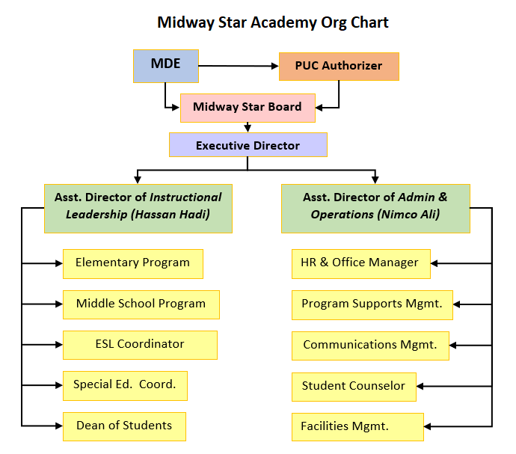

Professional Development of School Administrators
Mohamed Warsame – was hired in March 2020. He has an administrative license, file folder # 495819, for Principal K-12. His professional development is guided by licensure requirements. Mr. Warsame is pursuing his doctorate in Education, so his doctoral program will guide his professional development.

Staff and Parent Satisfaction
Parent Survey FY2023 on Satisfaction with Midway Star Academy: Results of 15 Questions
Feedback was collected about parent satisfaction via the annual parent satisfaction survey. Parents were asked 15 questions regarding the education their children receive at Midway Star. Overall, parents are very satisfied with the education their children are receiving. We averaged a 97% satisfaction rating with 100% of families indicating they would recommend the school to family and friends.

Survey Question | Very | Somewhat satisfied | Sometimes not | N= | # Very+ Somewhat | % Very& Somewhat
1 How happy is your child at Midway Star Academy? | 28 | 4 | 3 | 35 | 32 | 91.0%
2 How safe is your child at Midway Star Academy? | 34 | 1 | 0 | 35 | 35 | 100%
3 How welcome do you feel at Midway Star Academy? | 31 | 3 | 1 | 35 | 34 | 97.0%
4 How comfortable are you talking to the school's administration? | 33 | 2 | 0 | 35 | 35 | 100.0%

5 How comfortable are you talking to your teacher's teacher? | 26 | 6 | 0 | 35 | 35 | 100%
6 How satisfied are you with the communication you receive about your child? | 33 | 2 | 0 | 35 | 35 | 100.0%
7 Does your child have the right amount of homework each night? | 25 | 7 | 3 | 35 | 32 | 91.0%
8 Do you feel your child is fairly treated by adults at the school? | 31 | 4 | 0 | 35 | 35 | 96.0%
9 How satisfied are you with the school's bus service? | 30 | 5 | 0 | 35 | 33 | 94%
10 How satisfied are you with the school's special education program? | 20 | 2 | 1 | 23 | 22 | 96.0%
11 How satisfied are you with the school's EL program? | 23 | 4 | 2 | 29 | 27 | 93.0%
12 How satisfied are you with the school's Title I school wide program? | 22 | 5 | 1 | 28 | 27 | 96%
13 Overall, How satisfied are you with the education your child (or children) receives at Midway Star Academy? | 29 | 4 | 2 | 35 | 33 | 94.0%
14 Would you recommend Midway Star to your family or friends? | 35 | 0 | 0 | 35 | 35 | 100.0%
15. Are you satisfied that the school has communicated the school's mission to you? | 33 | 2 | 0 | 35 | 35 | 100.0%
Total -Average of All Questions |  |  |  | 500 | 485 | 97%

Curriculum, Program, and Innovative Practices
Personalized Student-Centered Learning:
Innovative practices and programs are based on a personalized student-centered model combined with use of data to identify individual needs have served to improve performance each year of the turnaround. The school implemented a $100K grant from the Bush foundation to support innovative practice. In addition, attention school wide to effective ELL strategies is central to the comprehensive strategy to drive achievement. Individualized interventions and adaptive programs work to close skills gaps. Midway Star Academy uses Imagine Learning, an on-line intervention program that supports multiple languages including Somali. Progress only occurs when students are engaged so Midway Star Academy uses a blend of strategies including small group learning, on-line programing, and hands-on project-based learning (FUSE lab for example.) Teachers receive on-going professional development and coaching specifically aligned with student needs and goals, along with time for regular collaboration with colleagues. 21st century learning is essential to teaching and learning at Midway Star Academy. The school bases specific projects on the UN Sustainable Development Goals and participated in myworld360.

Culturally Relevant Curriculum and Instruction:
The core identity of Midway Star Academy surrounds Somali Language and Culture. All students receive language instruction in either Somali or Arabic. Imagine learning supports Somali language. All staff receive training and resources related to Somali culture. The physical environment in the school honors this core identity - Somali art is displayed throughout the school, signage is in English and Somali, posters depict language and literature. The school provides a weekly class for parents teaching them to support student learning in the home in their native language. This not only empowers parents in meaningful ways, but it also serves to bridge the language gap between child and parent. Many parents speak only Somali, and children speak English or English and Somali. Every effort has been made to recruit and retain Somali professionals, especially licensed teachers. Our goal is to focus on student learning and cultural competence, as researcher Landon-Billings recently stated in a 74 million article “The teacher's role is not merely to help kids fit into an unfair system, but rather to give them the knowledge and dispositions to change the inequity.”
In middle school the Summit Learning Platform which is foundational to our program is reflective of all 7 components in the description above. Components of Summit learning are mentoring, projects and self-direction. Students demonstrate proficiency in cognitive skills, content knowledge, and Habits of Success.
Integration of inquiry-based learning opportunities provide ample opportunity for critical thinking and problem solving across grade levels and subjects. Utilization of rigorous standards-based curriculum develops effective oral and written communication and assessing and analyzing information.

10. Future plans and next steps
Midway Star will be hiring 2 instructional coaches to support teachers in achieving success, ensuring that their lessons align with and adhere to state academic standards and curriculum requirements. Their primary responsibilities will be to collaborate with teachers to help them achieve their professional goals. They will build strong relationships with staff, provide feedback on teaching practices, and mentor them. They help teachers to plan lessons, model effective instructional strategies, and provide ongoing coaching to help teachers improve their teaching practice. The instructional coaches will play a crucial role in not only improving student outcomes but in enhancing teacher retention as well.
Additionally, this past year, Midway Star felt the impact of the current teacher shortage. To prepare for next year, Midway Star will look at recruiting effective, experienced, and qualified teachers from overseas. We need to recruit highly qualified teachers from everywhere, including from overseas, to meet our students' academic and social-emotional needs to help improve our academic performance overall.

11. Finances

Midway Star FY23 Annual Report Finances Section
Information presented below is derived from fiscal year 2022-23 audit submission figures. The 2022-23 audit will be completed and presented to the Minnesota Department of Education.

FY2023 Finances | Fund 1 (General Fund) | Fund 2 (Food Program Fund) | Total Fund 1 and 2
Total Revenues | $8,041,449.14 | $469,102.93 | $8,510,552.07
Total Expenditures | $7,097,016.61 | $448,596.06 | $7,545,612.67
Net Income | $944,432.53 | $20,506.87 | $964,939.40
Total Fund Balance | $3,596,303.25 | $125,092.85 | $3,721,396.10

Overview
Overall, the school is doing well financially and is positioned to provide their students with the resources they need to reach their potential academically.
Revenues
Revenue for FY23 was over budget by approximately 1.5% due to additional students attending the school when compared to the students used to calculate revenue in the budget.
Expenses
Expenses for FY23 were over budget by approximately 3% due to the school investing some additional funds into the school when comparing to budget.
Net Income and Fund Balance
The school had a strong year financially ending with a net income of $964,939.40. The school fund balance percentage is 49.32% which is extremely strong. Most charter schools strive to have a minimum fund balance of 25% and the school is far exceeding that percentage.
Dieci School Finance, LLC provides accounting services for Midway Star Academy.
For questions regarding school finances and for complete financials for 2022-23 and/or an organizational budget for 2023-24, contact:
Position: Financial Management Vendor
Contact info: Dieci School Finance; 2489 Rice Street, Suite 202; Roseville, MN 55113
Phone: (651) 309-2233
Email: robert@diecisf.com

